**MID TERM PROJECT REPORT**

(2020-21)

**NEXUS**



Department of Computer Engineering & Applications

**Institute of Engineering & Technology**

**Team Members**

Anurag Tripathi(181500758)

Himanshu Gautam(181500269)

Ashok Singh (181500146)

***Supervised By***

**MD FARMAN**

Technical Trainer

**Department of Computer Engineering & Applications**



**Department of computer Engineering and Applications**

**GLA University, Mathura**

**Chaumuha, Mathura – 281406**

**CERTIFICATE**

Certified that this is a bonafide record of the project work titled

**NEXUS**

done by

Anurag Tripathi(181500758)

Himanshu Gautam(181500269)

Ashok Singh (181500146)

of VI semester Computer Science & Engineering in the year 2019 in partial fulfilment of the requirements for the award of Degree of Bachelor of Technology



in Computer Science & Engineering of GLA University, Mathura.

**MD FARMAN**

**Technical Trainer**

(Project Mentor)

**SYNOPSIS**

Not getting room of choice has been always issue in hostel booking so here we came with a solution.

Enter your current hostel detail and details of hostel you want to exchange.

Someone who is interested would contact you soon!

Yes!! It’s that simple.

**ACKNOWLEDGEMENT**

It is our pleasure to be indebted to various people, who directly or indirectly contributed in the development of this work and who influenced our thinking, behavior and acts during the course of study.  
We express our sincere gratitude to **GLA University** for providing us an opportunity to undergo this Project as the part of the curriculum. We are thankful to **Mr. Md farman** for his support, cooperation, and motivation provided to us during the training for constant inspiration, presence and blessings.

Lastly, we would like to thank each of the teammates with whom we shared our day-to-day experience and received lots of suggestions that improved our quality of work.  
We perceive as this opportunity as a big milestone in my career development. We will strive to use gained skills and knowledge in the best possible way.



**Names and Signature**

Anurag Tripathi(181500758)

Himanshu Gautam(181500269)

Ashok Singh (181500146)

**ABSTRACT**

Not getting room of choice has been always issue in hostel booking so here we came with a solution.

Enter your current hostel detail and details of hostel you want to exchange.

Someone who is interested would contact you soon!

Yes!! It’s that simple.

.

**Table of Contents**

**Content**

Approval

Declaration

Acknowledgement

Abstract

Table of content

List of figure

**CHAPTER**

**CHAPTER 1: INTRODUCTION**

1.1 Introduction

1.2 Objectives

1.2.1 Audience target

1.2.2 Future prospects

**CHAPTER 2: PROJECT OVERVIEW**

2.1 Project overview

2.2 System Requirement

2.3 Problem Definition

2.4 Project function

2.5 User characteristic

**CHAPTER 3: FUNCTIONAL REQUIREMENT** 3.1 Login Module

3.2 Signup Module

3.3 Upload video

3.4 subscribe creator

3.5 like/dislike video

3.6 System attributes

**CHAPTER 4: SYSTEM REQUIREMENT**

4.1 Database

4.1.1 front end technologies

4.1.2 back end technologies

4.1.3 Tables

* **FIGURES**

Screenshots

* **TESTING**
* **CONCLUSION**
* **FUTURE SCOPE**
* **REFERENCE**

**Introduction**

**1.1 Introduction**

Not getting room of choice has been always issue in hostel booking so here we came with a solution.

Enter your current hostel detail and details of hostel you want to exchange.

Someone who is interested would contact you soon!

Yes!! It’s that simple.

**1.2.1 Audience target**

The audience for the project will all people who lives in hostels.

**1.2.2 Future prospects**

Once the audience reach has increased we can approach more sponsors so that our user as well as our creator both can enjoy best.

**2.1 PROJECT OVERVIEW:**

Not getting room of choice has been always issue in hostel booking so here we came with a solution.

Enter your current hostel detail and details of hostel you want to exchange.

Someone who is interested would contact you soon!

Yes!! It’s that simple.

**2.2 SYSTEM REQUIREMENT SPECIFICATION**

The software requirement specification is a document that describes the external requirement for any system. The requirement analyst has to identify the requirements by talking to the clients and understanding and responding to their needs. The requirement phase translates the ideas of clients into a formal document. The inputs are gathered from different resources. Input given by the clients may not be consistent. It might change according to the modern requirements.

**2.3 PROBLEM OVERVIEW**

Not getting room of choice has been always issue in hostel booking so here we came with a solution.

Enter your current hostel detail and details of hostel you want to exchange.

Someone who is interested would contact you soon!

**2.4 PROJECT FUNCTION**

The main aim of the project to show more content and less ad. As data users are increasing each day it’s the perfect time to move toward something that has great future.

**2.5 USER CHARACTERSTICS**

The user of this project is supposed to be fairly educated about the usage of the computers. He should understand how to store items and he should have knowledge about various products so that they could be saved. A person who has no knowledge of computers will find it difficult to understand the system. But with a little knowledge it will be very easy to handle the project.

* **Uploader:**

**Description of project:**

Uploader can upload his details.

* **VIEWER:**

**Description of viewer:**

Viewer can watch and contact the uploader.

**4. SYSTEM REQUIREMENT**

**3.1 Login Module**

* Input:

Donor enters the login id and password

* Process Definition:

Checks login if and password is valid or not.

* Output:

User is directed to next page where he can watch videos or upload.

**3.2 Signup Module**

* Input:

User enters their details to create new account.

* Process Definition:

Checks whether he entered all the details or not.

* Output:

User is directed to next page where he can view all the available Videos.

**3.3 Upload Video**

* Login

After successful login user can click on upload button to upload.

* Signup

After successful signup user can directly click to the upload button to upload.

* Upload button

User can choose and upload videos after clicking on this button.

**3.4 Subscribe creator**

* SUBSCRIBE

Once user logged in/ signed up he/she can subscribe to the creators that he/she likes.

After subscribing users can directly access their creators.

**2.6 SYSTEM ATTRIBUTES:**

• **Portability:**

The Online Mobile Shopping shall run in any Microsoft Windows environments that contain ASP.net platform and the Microsoft SQL.

• **Reusability:** Our system is reusability system since a segment of source code that can be used again to add new functionalities with slight modification.

• **Testability:** Our system is testability system since it supports different types of testing methods.

• **Other Requirements** There are no other requirements.

**4.1 DATABASE  
 DATABASE DESIGN:** Databases are the storehouses of data used in the software systems. The data is stored in tables inside the database. Several tables are created for the manipulation of the data for the system. Two essential settings for a database are-

•  Primary Key - The field that is unique for all the record occurrences.

•  Foreign Key -the field used to set relation between tables.

Normalization is a technique to avoid redundancy in the tables.

1. **4.2 SYSTEM TOOLS**

The various system tools that have been used in developing both the front end and the back end of the project are being discussed here.

**3.3.1.FRONT END:**

HTML, CSS, JAVASCRIPT, BOOTSTRAP are utilized to implement the frontend.

•  HTML (Hyper Text Markup Language)  
HTML is a syntax used to format a text document on the

•  CSS (Cascading Style Sheets)  
CSS is a style sheet language used for describing the look of a document written in a markup language.

• Bootstrap  
 Bootstrap is a free and open-source CSS framework directed at responsive, mobile-first front-end web development. It contains CSS- and JavaScript- based design templates for typography, forms, buttons, navigation and other interface components.

• Java Script  
 JS is a dynamic computer programming language. It is most commonly used as part of web browsers, whose Implementations allow client-side scripts to interact with the user, control the browser, communicate asynchronously, and alter the document content that is displayed. Java Script is used to create pop- up windows displaying different alerts in the system like “User registered successfully”, “Password do not match” etc.

**4.1.2 BACK END**

The back end is implemented using MySQL which is used to design the databases and PHP which is used to do server side scripting.

•  MySQL  
MySQL is the world's second most widely used open-source relational database management system (RDBMS). The SQL phrase stands for Structured Query Language. An application software called Navicat was used to design the tables in MySQL.

•  PHP(Hypertext Preprocessor)  
PHP is a widely-used open source general-purpose scripting language that is especially suited for web development and can be embedded into HTML.

**4.1.3 TABLES**

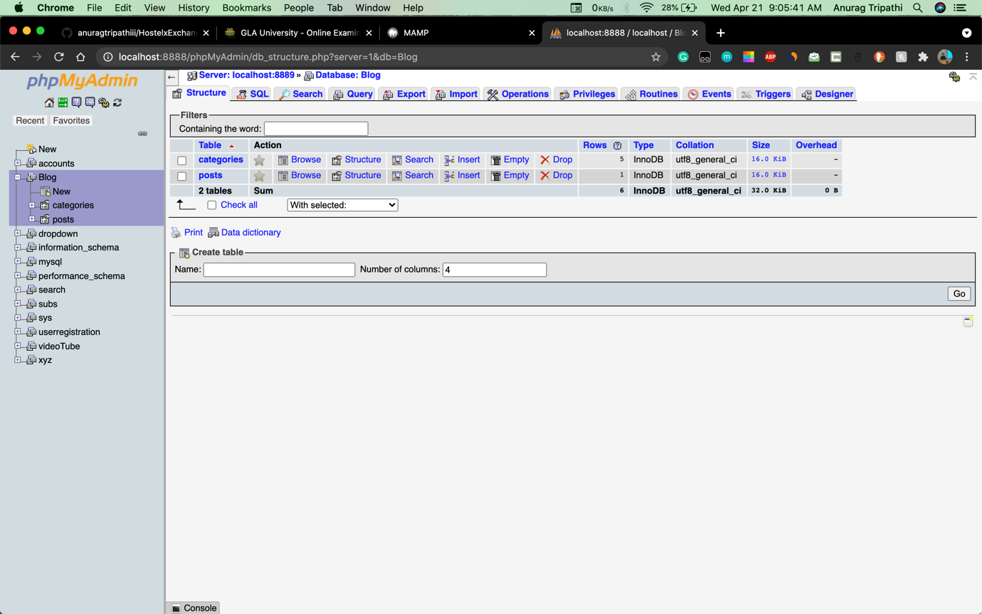

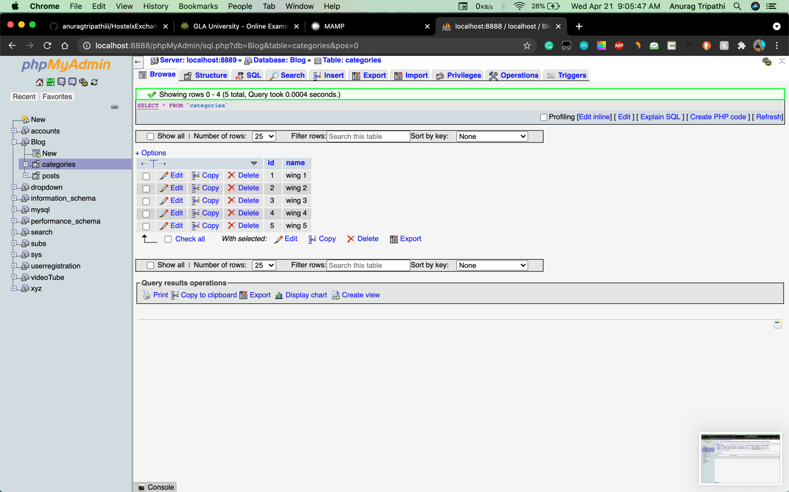

**Categories**

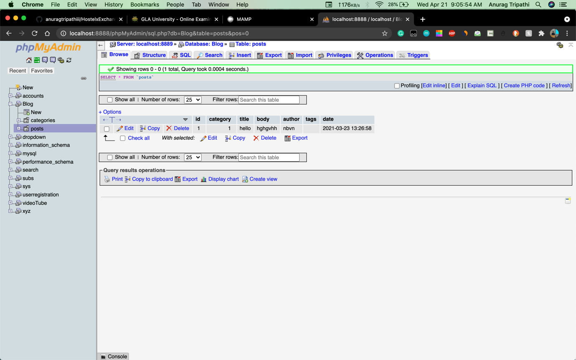

**TESTING**

Testing is a group of techniques to determine the correctness of the application under the predefined script but, testing cannot find all the defect of application. The main intent of testing is to detect failures of the application so that failures can be discovered and corrected. It does not demonstrate that a product functions properly under all conditions but only that it is not working in some specific conditions.

**Unit Testing**

Unit testing involves the testing of each unit or individual component of the software application. It is the first level of software testing. The aim behind unit testing is to validate unit component with its performance.  
A unit is a single testable part of a software system and tested during the development phase of the application software.

This testing aims to test the correctness of isolated code. A unit component is an individual function or code of the application. White box testing approach used for unit testing and usually done by the developers.

**Integrated Testing**

Integration testing is the second level of the software testing process comes after unit testing. In this testing, units or individual components of the software are tested in a group. The focus of the integration testing level is to expose defects at the time of interaction between integrated components or units.

Unit testing uses modules for testing purpose, and these modules are combined and tested in integration testing. The Software is developed with a number of software modules that are coded by different coders or programmers. The goal of integration testing is to check the correctness of communication among all the modules.

**CONCLUSION**

The system has been developed with much care and free of errors and at the same time it is efficient and less time consuming.

Not getting room of choice has been always issue in hostel booking so here we came with a solution. Enter your current hostel detail and details of hostel you want to exchange. Someone who is interested would contact you soon!

Yes!! It’s that simple.

**FUTURE SCOPE**

The website has many future scope further. We may add the location details of the videos. The second feature we can add is we make an watch later button. We can even add a share button which will help people to share content directly to there friends. We can further expand the project to and add many different features in it and vastly make it helpful.

**REFERENCE**

* [www.wikipedia.org/](http://www.wikipedia.org/)
* [www.udemy.com/](http://www.udemy.com/)
* [www.stackoverflow.com/](http://www.stackoverflow.com/)
* [www.google.com/](http://www.google.com/)